- Choosing topic

- Identifying Gaps
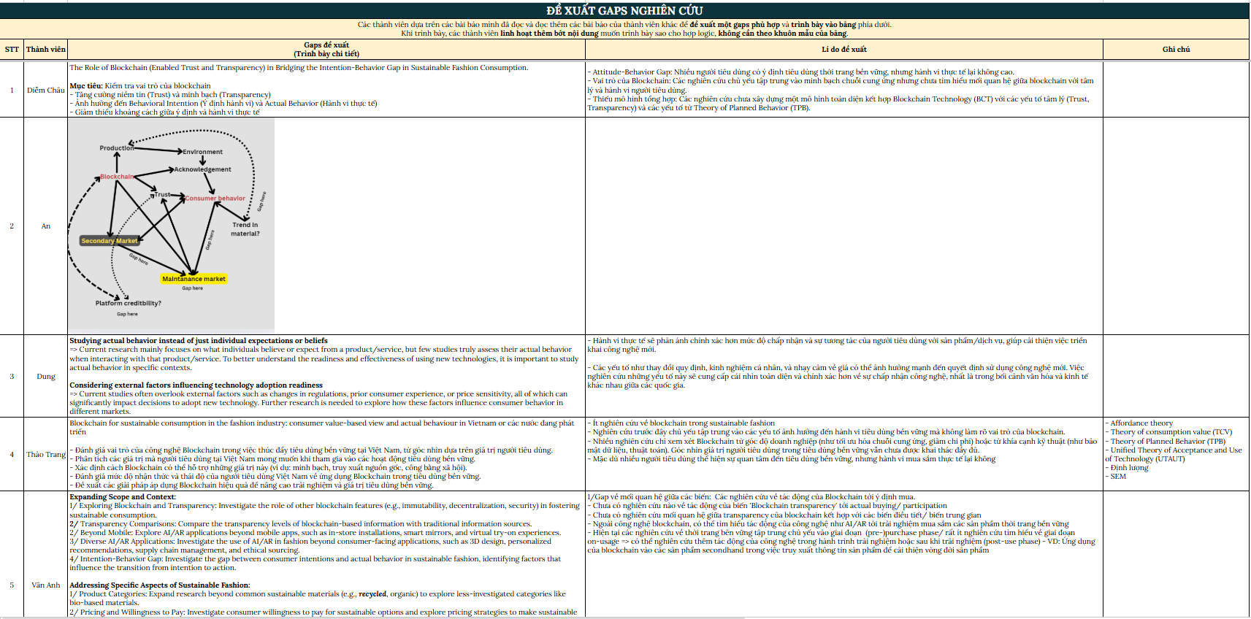

- Literature Review
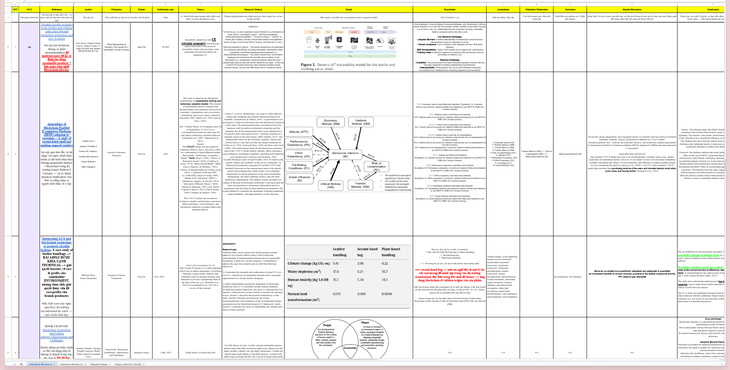

- Mapping
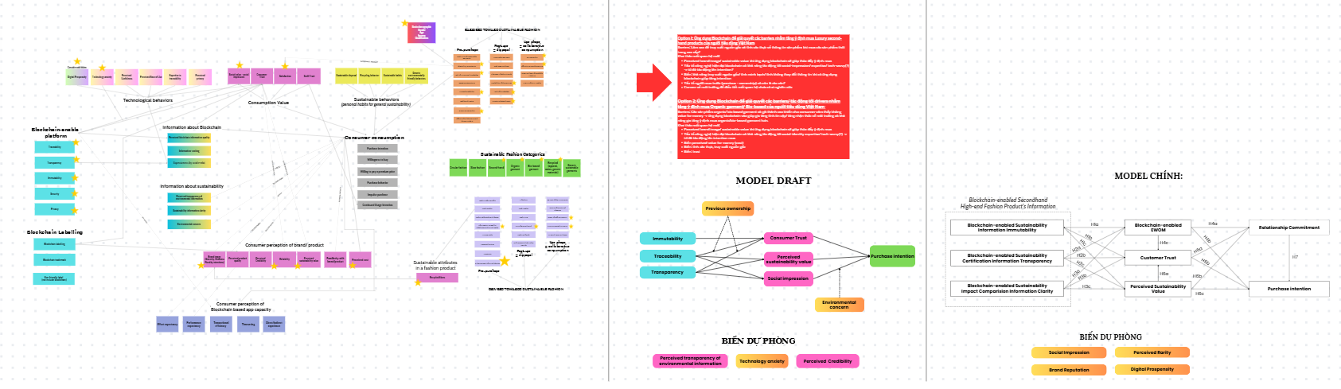
And finalising model
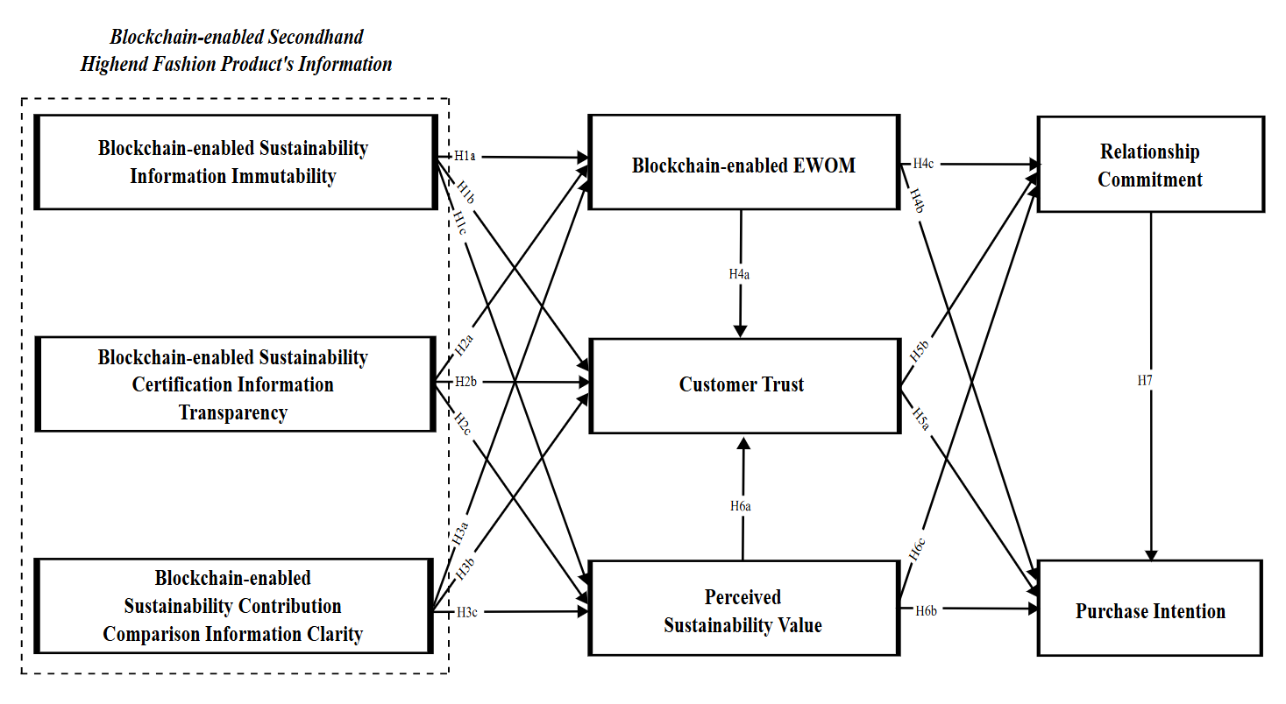

- Collecting Survey


- And then run 7749 models

- Writing, finalising, revising and finding suitable journals to submit, then submit for publications and revise and submit again and revise and revise and revise and revise and finally got published ta da


